Weather Instruments Info 2

Subject:  Related Subjects: | Grade Level(s):  Length of Lesson: | Type: Inquiry / Design / Project  Keywords:

Lesson Overview
Use this section to describe at a high level what the lesson is. Should be no more than 3-4 lines.

Lesson Focus
What is the central question or phenomenon being investigated? What problem are they trying to solve?

Lesson Objective(s) | The students will build a weather vane and an anemometer (can be separated into two projects). They will learn the importance of meteorology and how they can study the weather.

Lesson Timing

5 minutes | Introduce the Lesson
30 minutes | ...

Materials | - Craft Sticks  - Pins  - ¼” x ¼” balsawood  - 1/8” x 1/8” balsawood  - Small cups  - Tape  - Thread  - Index cards  - straw
Instructor Prep | - Step 1
Related Resources | - List related lessons/ppts etc available from USC or outside, trusted orgs

Lesson Plan

Introduction
Meteorologists study weather patterns and try to predict the weather as best as possible for the safety and health of people as well as the protection of businesses. To properly observe and predict the weather, scientists first have to be able to quantitatively measure the weather. Anemometers are tools that measure wind speed. Wind vanes are tools that measure the direction of the wind.

Procedure
- Start the project by building the base. Simply, ~4 inches of the larger balsawood needs to be standing vertically. The base needs to hold this piece vertically. (I used three craft sticks in an “I” form).
- Building the rotating parts
  - Anemometer
    - Start with two 1-foot long pieces of the smaller balsawood. Make an ‘X’ with them and keep them in this position by wrapping thread and tying it around the intersection. Push a pin through the junction. The anemometer will spin on this pin.
    - Tape or glue four cups to the each end of the ‘X’. Make sure the cups all point in the same direction (clockwise or counterclockwise). Make sure the cups are open parallel to the ground, not opening up or down.
      - I poked two holes about 1 inch apart parallel to the face of the cup and pushed the balsawood through the holes, then taped it for security.
    - Attach to base
      - Place the ‘X’ on top of the vertical piece by pushing the pin from the junction into the ¼” balsawood.
  - Wind vane
    - Cut out and arrow head and tail from the index card
      - Cut slits into each end of your straw. Fit the arrow head on one side and the tail on the other side. Secure them with tape if you feel necessary
    - Push a pin close to the center of mass of the straw.
    - Attach to base
      - Place the wind vane on your base by pushing the pin into the vertical ¼” balsawood. It should spin on this pin.

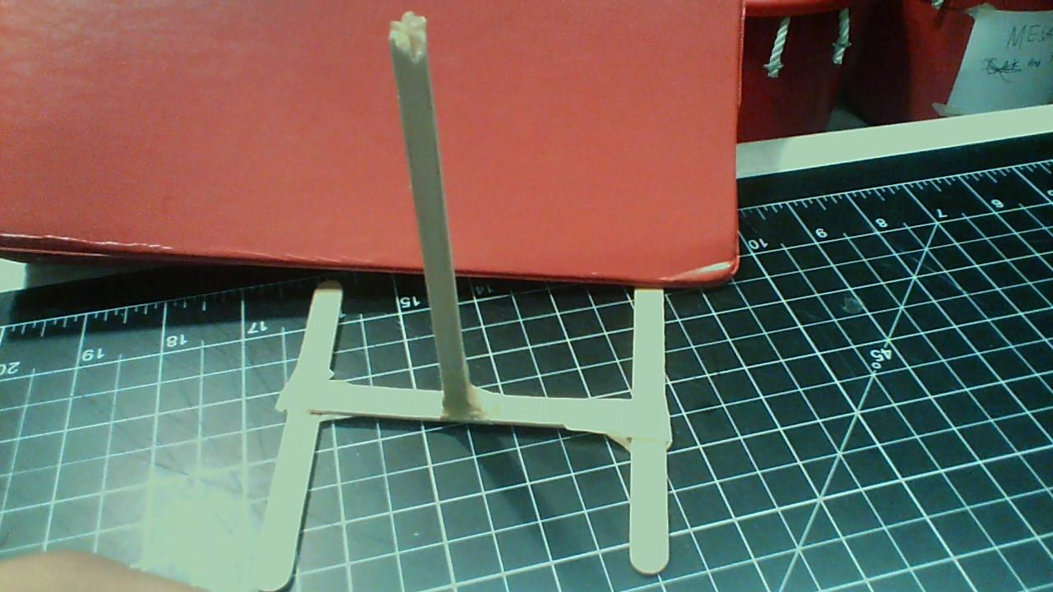

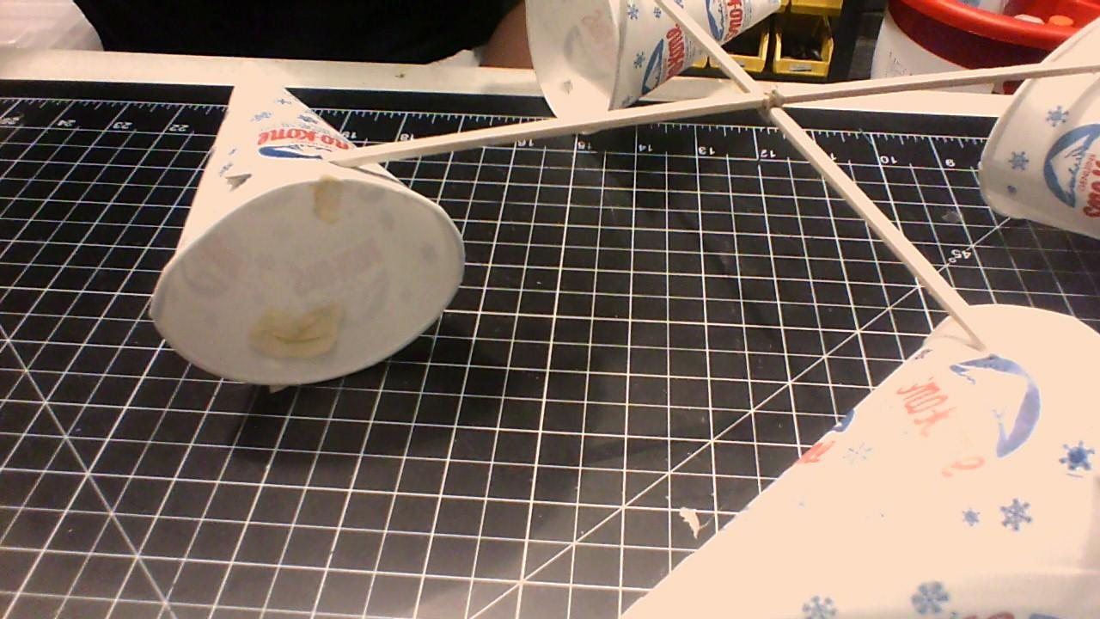

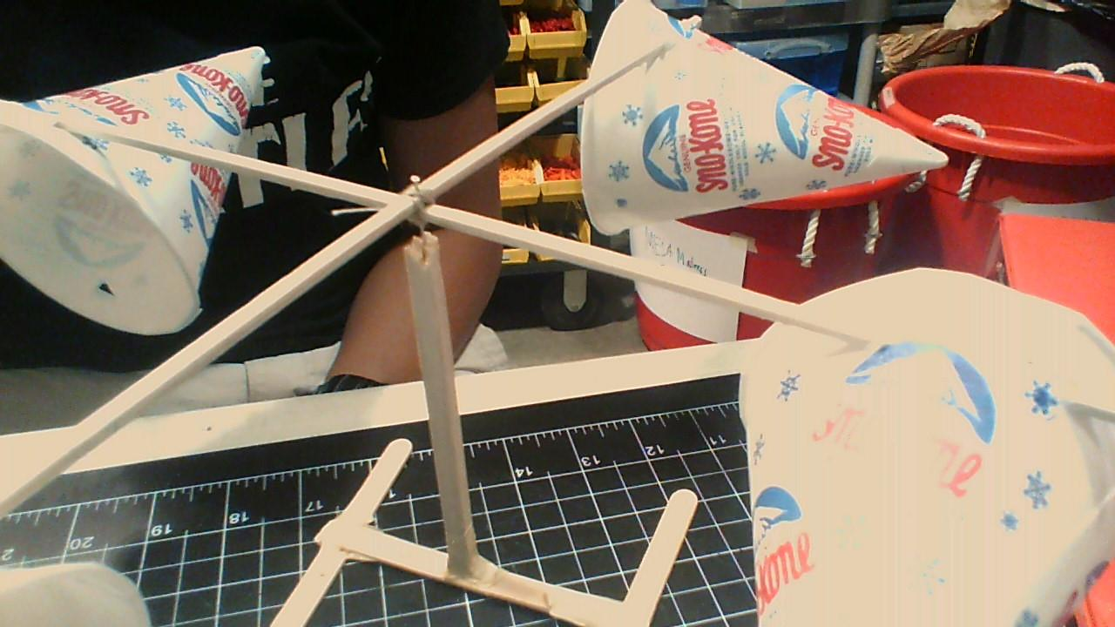

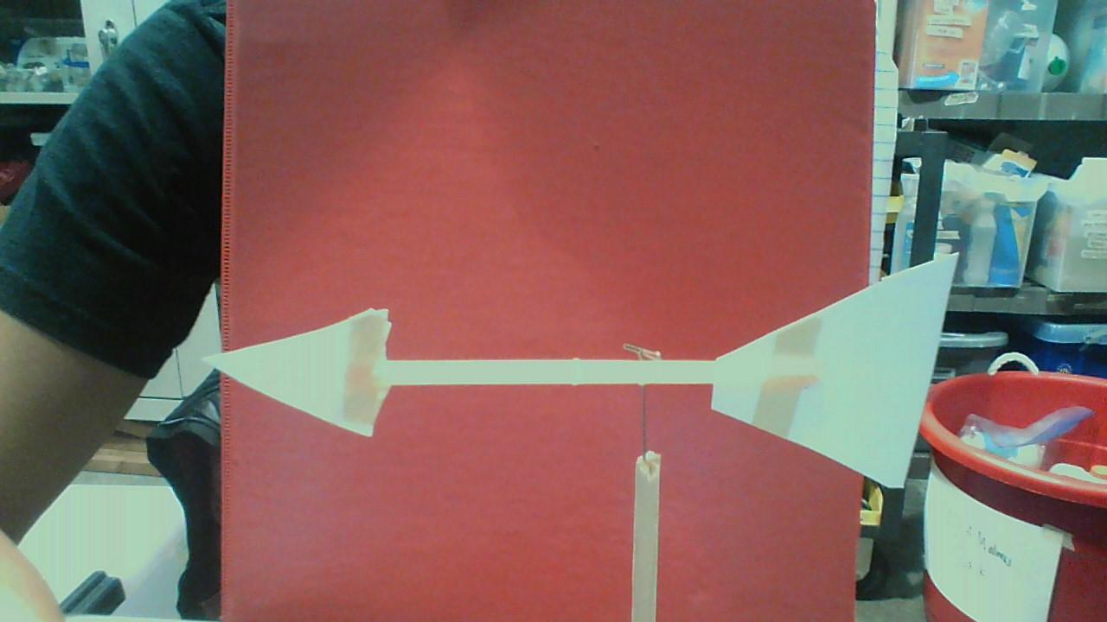

Wrap-up
End the lesson with some final discussions about what students designed/discovered. Connect their activity back to the focus question/problem, real world examples, and STEM careers.

Also include notes about any special cleanup considerations

Lesson Background for Teachers

Suggested Real-World STEM Connections
- List possible related Role Models in STEM (with details and links to more reading). Give suggestions for examples of scientists/engineers who are from underrepresented groups in STEM in related careers.
- List related real-world engineering problems and examples

Lesson Variations and Options
Include descriptions of alternative methods or ways to present things.

Explanation
Describe the background concepts and explanations behind the lesson. This can be more in depth than a teacher/instructor would actually share with students.

Key Concepts and Vocabulary
- Word 1: Grade Appropriate Definition
- Word 2: Grade Appropriate Definition

Safety Notes
- Safety instruction

